Friday 18th February
SD Task – Cross Curricular ICT
- School Policy on cross-curricular ICT activities?

There is no specific policy relating to cross-curricular ICT at Clevedon School, however it is encouraged that ICT is used across the school. ICT activities are always used for cover lessons.

In the duration of time whilst I was on placement at the school departmental blogging was becoming very popular with students and staff. The take up of the blogging has been great; however a question to ask is that the use of this technology is only happening because the school has no VLE.

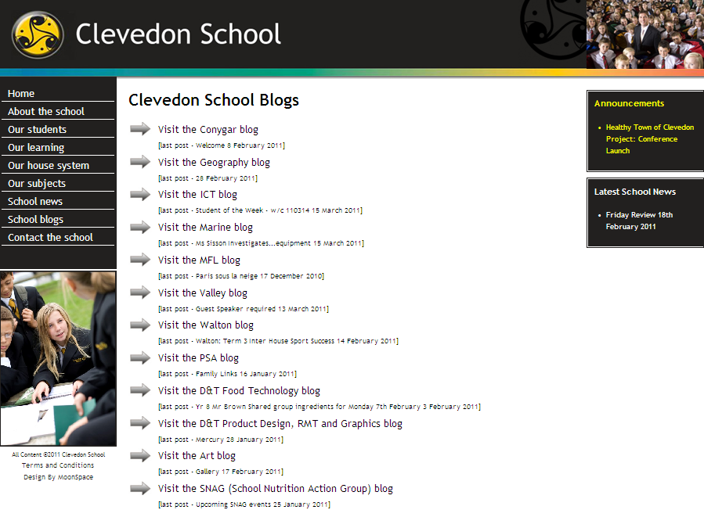
Blog Homepage – Clevedon School Website.

The is a cloud based room booking system in place that shows availability of all of the ICT suites within the school, taking into account the specific ICT time and releasing ICT department teaching rooms when they are free to allow maximum use of the facilities available.

- How are teachers’ encouraged and supported in using ICT resources?

Staff from the ICT department, along with some individual members of staff across the school with specialist knowledge is the main support for staff that use ICT resources.
A great deal of inspiration for teachers’ use of ICT at Clevedon School has come from the “Little book of superb sites” that has been compiled by the Head of ICT: http://ictevangelist.posterous.com/little-book-of-superb-sites-v1.

Other ideas can come from online sources such as the TES resource bank or other subject specific resource libraries online. Students use subject specific software/flash based products such as “my maths” widely across KS3 at the school.

- Which departments make good use of ICT facilities and which make little use?

Modern Foreign languages - Use ICT mainly for vocabulary work where students will make a PowerPoint about a given subject and they can use Google translate to help them with the task. They also use data projectors in the classroom to support their teaching.

Maths – Use ICT in the classroom to support the use of electronic whiteboards and use “my maths” as a teaching aid and as a method of revision support.

Food Technology – Use blogging on the school website to communicate recipe information to both students and parents.

- Examples of Cross Curricular ICT observed

French Lesson (IT Suite) – I observed a French lesson where students were tasked with creating a PowerPoint presentation that summarised the vocabulary that is used to describe the weather. They had to use images and text to present them.

It was difficult to see what the eventual aim/outcome of the task was going to be, as an observer it appeared that ICT was being used with the intention of helping students to become more engaged with the subject content. I am not sure it was effective as many students were playing on games and partaking in other activities online that caused them to loose focus on the task in hand.

Asking students to search for images is always a recipe for disaster when it comes to keeping the on task; I am not sure whether such an activity is an efficient use of lesson time.

Maths Lesson (Electronic Class Board) – I observed a Maths lesson where the teacher was using the smart board for his starter activity. It was game where students had to guess the answer to the question and select it by touching the whiteboard.

It was a very simple game however students appeared keen to take part. The use of the technology would have allowed for the teacher to cover a greater number of questions in the time allowed for the task. It also helped students to be engaged with the activity.

- Conclusion
Cross-curricular use of ICT at Clevedon School is very much in its early stages of development. I think that the fact the school does not have a VLE system has meant that there has been less pressure on staff to use ICT in their teaching.
It is important that ICT is used as a resource to support/scaffold learning and isn’t just used as a “fun” activity for students on a Friday afternoon.
Teachers should think carefully before using ICT in their teaching, and weigh up the pros and cons of integrating it into a lesson and evaluate whether it is appropriate for use and will support the learning outcome of a lesson.
From various observations of non-ICT specialists teaching in ICT suites it is clearly obvious that training in ICT classroom management is something that staff could really benefit from; especially training staff how to use the remote monitoring software.

